Call for Proposals
National Museum of Marine Science & Technology / Keelung City Government
2016 International Marine Environment Art Project in Keelung, Taiwan
Envisioning the Future of Our Oceans”

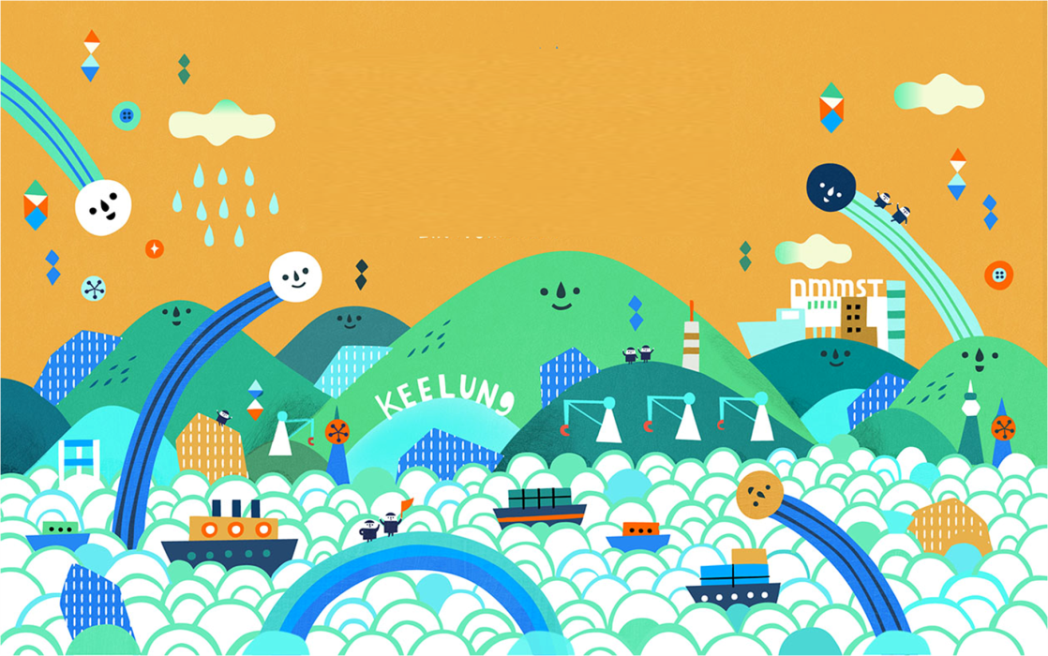

Artists from all countries are invited to send a proposal for a site-specific outdoor sculpture installation that will raise awareness about the future health of our oceans, and in particular relate to the Badouzi community of Keelung City, Taiwan. Badouzi is located at the port of Keelung, celebrating its 130th year in 2016. Keelung Port is on the northeast coast of Taiwan and opens to the Pacific Ocean. Badouzi is a fishing village where most of the people traditionally make their living from the sea. The port of Keelung, first officially established in 1886, grew to become the second largest port in Taiwan today, and it is the major port on the eastern side of Taiwan. The Eastern coast of Taiwan remains greener and less urbanized even in this time of ocean acidification, global warming and increasing pollution. By striving to reverse current conditions and improve the ocean environment, we hope to preserve the future health of our oceans that are at the heart of life on earth. The NMMST is a newly opened museum with exhibitions and programs about marine science and technology and a popular tourist destination in Keelung, Taiwan. Here's the museum website:
National Museum of Marine Science & Technology (NMMST) http://www.nmmst.gov.tw/enhtml/index

The artists selected for this art project will create their artworks during a 25-day artist in residency in Keelung, Taiwan, from May 12 – June 6, 2016. We expect to select 6 foreign artists and 2 Taiwanese artists based on the proposals received. 2016 will be the 2nd year of this marine environment art project that is organized by the NMMST and supported with community development and economic improvement funds from national and local government. The selected artists will work with community residents, visitors and volunteers to create large-scale outdoor sculpture installations that will raise awareness about ocean environmental issues, develop community pride, and attract more visitors to the area. For 2016 the artworks will be about celebrating the port of Keelung and preserving the future health of the world’s oceans.

Artworks selected for this project will be site-specific and located in public outdoor spaces such as coastal parks, plazas, beaches, land around existing museum buildings or other sites selected with the artists, the curator and staff of the Museum. The artworks should encourage learning by doing and be interactive in some way; for example the artwork could function as a play area or outdoor seating or have interactive educational components. The sculpture installations will be made with local natural materials or recycled materials that are sustainable and not harmful to the environment. The artworks should be made to last for one year or more, but be biodegradable so that they can decompose over time and be recycled into the environment. Artists will work alongside the other international artists and with local residents and visitors in Keelung, Taiwan.

Theme: Envisioning the Future of our Oceans
Deadline for Entries: Feb. 15, 2016
Artists will be selected and notified by March 15, 2016
Installation and Residency in Keelung, Taiwan: May 12, 2016 (artists arrive) – June 6, 2016 (artists depart)

Dates of the Exhibition: June 5, 2016 (opening ceremony); June 4 and 5, 2016 (Opening weekend activities with the artists). The exhibition will stay on display until September 2016, and the artworks can continue to be enjoyed into the next year.

Selected Artists will receive the following:
- Artist’s Award of NT$60,000 (about US$2,000) for creating the artwork and participating in the public programs and working with community residents, volunteers and visitors. The Museum will cover the tax to the Taiwan government, and artists will receive the exact amount of NT$60,000. Taiwanese artists will also receive NT$60,000 for the Award and pay their own income tax and NHI (national health insurance).
- Round trip economy airfare from the artist’s home to Taipei (Taoyuan International Airport) and then local transportation to Keelung, Taiwan. Taiwanese artists will receive train fare or other reimbursement for their expenses to come from their home to Keelung. Detailed travel instructions will be sent to selected artists, and artists must get the approval of the curator before booking tickets and keep all receipts and boarding pass for reimbursement when they arrive in Keelung. Reimbursement will be in Taiwanese dollars calculated at the exchange rate on the date that the artist purchased the ticket. (Without the expense of visa, passport application, travel insurance and additional transport costs)
- 25 days of accommodations in Keelung with other international and Taiwanese artists. Each artist will have a separate bedroom, and bathroom, kitchen and living room space may be shared.
- Meals will be provided for breakfast, lunch and dinner, and more information about meals will be sent to the selected artists.
- Local transportation around Keelung and to scheduled site-seeing trips with the artists and volunteers will be provided.
- Volunteer help from school children and adults in the community as well as museum visitors to create the artworks. We also plan to have at least one adult volunteer to help each artist for the entire residency period. This adult volunteer will be able to speak English and Chinese. However, artists should be confident that they can make the proposed artwork by themselves.
- Help to find local free natural and biodegradable materials to make the artworks. Local natural materials include driftwood, shells, reeds, grasses, branches, stones, earth, sand, etc. Other possible biodegradable materials include natural rope, nets, natural fiber fabric, bamboo (it does not grow so much around Keelung but can be purchased) and wood. Artists should use only natural and biodegradable materials and eco friendly processes that will not harm the environment and encourage sustainability. Artists who need to purchase materials to make their artwork must consult with the curator about cost and availability in Keelung. The materials and processes that artists use should set a good example for the community, and we expect that artists will use mainly free natural and recycled materials.

Qualifications of Artists:
Artists who apply should have experience working with communities to create large scale site-specific outdoor sculpture installations in public settings and involve ordinary people in their thoughts and process. The artists should also have an interest and experience in making outdoor works related to ocean environmental issues. The selected artists should be able to speak English and be able to get along well with other artists, the local community and people of all ages and backgrounds. The selected artists should also be able to introduce their home culture to the community and share the environmental concerns in their own home environment.

Curator of the Exhibition:
Jane Ingram Allen, is an American independent curator, artist and critic, living in Taiwan from 2004 - 2012, and now based in California, USA. Jane first came to Taiwan as a Fulbright Scholar artist in residence in 2004 and 2005 and worked as an independent artist and curator from 2006-2012, starting the Guandu International Outdoor Sculpture Festival at Guandu Nature Park in Taipei in 2006 and the Cheng Long Wetlands International Environmental Art Project in Cheng Long village, Yunlin County, Taiwan in 2010. Jane will work with the staff of the NMMST and a community advisory committee to administer and coordinate all aspects of this project, including the selection of artists and supervising the art installations and public programs related to the art project. Jane has experience curating international art exhibitions and working with public art projects in communities around the world as well as being an art professor at colleges and universities and a curator and educator at museums and art centers. Jane is an environmental artist herself and has participated in many international artist-in-residency programs in the USA, Taiwan, Japan, Brazil, Tanzania, China, Indonesia, Nepal and Turkey. She has also curated several other environmental art exhibitions in Taiwan and the USA and writes about art for such magazines as SCULPTURE, PUBLIC ART REVIEW, ART RADAR ASIA, FIBER ART NOW and HAND PAPERMAKING.

To Apply:
Send the following in English by email to Jane Ingram Allen by the deadline of February 15, 2016, at this address: nmmstartproject@gmail.com
Proposals in Chinese may be sent to Ms. Sandy Chang at this address: b98105008@gmail.com

- Description of a proposed sculpture installation for the 2016 NMMST International Marine Environment Art Project (limit one page), sent as an attached .doc or .pdf file. Include dimensions and materials to be used in the proposed work.
- Artist Statement about your interest and experience working with communities and volunteers to create large-scale and interactive outdoor sculpture and installation artworks and about how your proposed artwork relates to the theme of preserving the health of our oceans (limit one page), sent as an attached .doc or .pdf file.
- Sketch or rendering of your proposed artwork (attached .jpg file of less than 1 MB)
- 6 images of previous related works (6 attached .jpg files of less than 1 MB each)
- Image list to give details about the 6 images. Include title of work, date made, materials used and location of the artwork (sent as an attached .doc file or .pdf file)
- CV or Resume in English (attached .doc or .pdf file) that details your education and art experience, awards and exhibitions. Be sure to include your name, present address and nationality.
NOTE: Each of these 6 items should be sent as individual files attached to email. DO NOT use Zip files or include them all in one .pdf or .doc file.

